Nassau County American Legion
DEPARTMENT OF NEW YORK
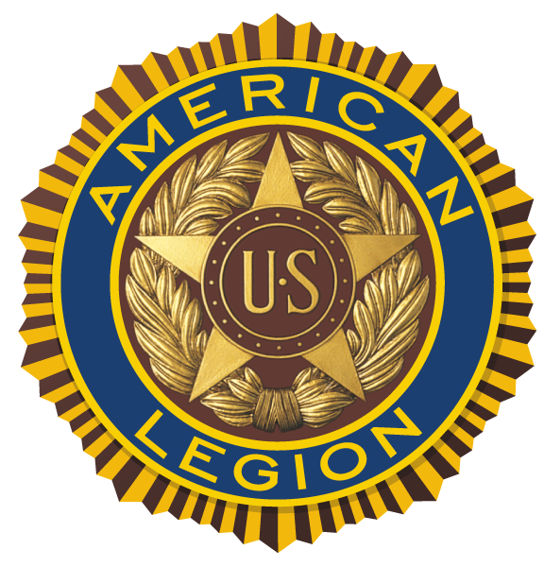

RE: 2026 Nassau County American Legion Scholarship

Dear Director of Guidance/Senior Class Counselor:

The Nassau County American Legion will award a $1,000⁰⁰ award to the senior class valedictorian with the most outstanding academic credentials in Nassau County. This award may be applied to freshman college tuition/expenses for the school year 2025-2026. Please note that only one scholarship application may be submitted by each school, and only one scholarship will be awarded. If your school has co-valedictorians, both names may be submitted, but only one will be eligible to receive the award if selected by the committee. The Nassau County American Legion Scholarship Committee shall be the sole judge of qualifications and selection of the award recipient.

The eligibility requirements are the same as in previous years, and are as follows:
- The candidate must be a 2026 graduate from a Nassau County private, parochial or public secondary school.
- The candidate must be the valedictorian of his or her class.
- The candidate must be registered to attend college in the fall term of 2026. If no college has been selected, the award will be held until college registration has been completed. Payment is made to the Bursar of the selected college.
- The candidate’s high school will submit the completed Profile Form and student transcript to Eric Spinner by USPS mail or by email to be received no later than May 1, 2026. Email to: ericmaven@gmail.com or mail to
Eric Spinner, Scholarship Chair, 36 Carole Avenue, New Hyde Park, NY 11040-1964
- All submissions must include:
- Applicant’s official high school transcript.
- Regents scores, ACT scores and SAT scores (if taken) of the candidate with a certification that candidate ranked first in his or her class, the name of the school in which candidate is valedictorian, and the name of the college, if selected. However, it may include matters pertaining to extracurricular and/or non-academic activities. The form on the back of this letter may be used for this purpose, or an additional document attached to the application.
- An optional letter signed by the principal, headmaster, dean, registrar or similar officer containing the name, address and telephone number of the school. If this is on the official transcript, this may be disregarded.
- A rating will be derived from a rubric, and the candidate with the highest rating will receive the scholarship. In the event of a tie, overall academic records and test scores will be considered to break the tie.
- The scholarship award check will be sent directly to the bursar/registrar of the college only after the winner presents the Nassau County American Legion Treasurer with a ‘paid’ receipt from the college in an amount equal to, or greater than, the scholarship amount and the college account information and mailing address.
- The candidate should be available to accept the scholarship at a meeting of the Nassau County American Legion in June 2026. The location and time of the meeting will be provided upon candidate selection.

If any additional information is needed, please do not hesitate to contact Scholarship Chair, Eric Spinner (information below).

To ensure that your student is not disqualified, please download and complete the Profile Form AND include a copy of the student’s transcript. The Profile Form can be downloaded in Microsoft Word using the link on the website:
NassauLegion.net/scholarship

Sincerely,
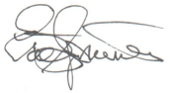

Eric Spinner, Education & Scholarship Chair
36 Carole Avenue
New Hyde Park, NY 11040
(516) 369-5313 (Mobile)
ericmaven@gmail.com

